Driving ecologically unequal exchange: A global analysis of multinational corporations’ role in environmental conflicts

*Marcel Llavero-Pasquina*

*Institut de Ciència i Tecnologia Ambiental, Universitat Autònoma de Barcelona, Spain*

[*marcelllaveropasquina@gmail.com*](mailto:marcelllaveropasquina@gmail.com)*; marcel.llavero@uab.cat*

# Abstract

Multinational corporations are being confronted by activists and scholars over their involvement in environmental conflicts and human rights violations. In response, many multinational corporations engage in human rights and ESG voluntary initiatives to mitigate their impacts and publicly bolster their contribution to society. These actions relate to disputed economic development theories which assert that foreign direct investment allows multinational companies to contribute to economic growth, human rights, and environmental well-being in so-called developing countries. To test these arguments, this article presents the largest statistical analysis on the role of multinational corporations in environmental conflicts based on data from the Global Atlas of Environmental Justice including more than 3,300 environmental conflicts and 5,500 companies. The results show how multinational corporations, overwhelmingly domiciled in the Global North, are involved in environmental conflicts in the Global South. Environmental conflicts with the presence of foreign companies disproportionately involve commodities with biophysical properties ideally suited to facilitate ecologically unequal exchange and show more socioeconomic impacts and worse outcomes than cases without foreign companies. These results cast doubt on the validity of corporate sustainability assessments and analysis based entirely on company self-reported data, and call for scholars to centre the lived realities of those resisting corporate extractivism to evaluate the socio-ecological performance of firms.

Keywords: Foreign Direct Investment, international trade, ecologically unequal exchange, environmental conflict, UN Global Compact, ESG

# Introduction

Only 7% of the material inputs of the global economy are recycled, the remaining 93% is extracted anew every year (Fraser *et al.,* 2023). This means new mines, oil wells, industrial plantations, airports, harbours, roads, and pipelines need to constantly be opened to meet the increasing demand for energy and material consumption (Martínez-Alier, 2012). Sustaining, reproducing and growing the economy demands extraction, and sparks environmental conflicts. Many of these new or expanded extractive operations are developed by multinational corporations (MNCs) foreign to the country of operation through a process known as greenfield Foreign Direct Investment (FDI). In 2022 alone, at least 36% of the total greenfield FDI, $500bn, was linked to energy, metals, and other extractive industries, with the rest going mostly to services and manufacturing,demonstrating the significant contribution of extractive sectors to FDI (UNCTAD, 2024). The academic field researching FDI is engaged in a lively debate on whether FDI benefits or harms the communities and ecosystems that host MNCs' extractive operations. On one hand, the *pollution halo hypothesis* proposes that the arrival of foreign MNCs in a country brings cleaner technologies and better management practices benefiting the local environment and economy (Zarsky *et al.,* 1999; Zhu *et al.,* 2016). On the other hand, the *pollution haven hypothesis* argues that MNCs search for competitive advantages in jurisdictions with lax environmental regulations, and thus FDI worsens environmental and social conditions in recipient countries (Balsalobre-Lorente *et al.,* 2019).

The pollution haven hypothesis has been related to the theory and quantification of ecologically unequal exchange (Hornborg, 1998; Doytch, 2020). This theory explains how asymmetric power relationships between countries and the globalisation of economic flows translate into a net resource drain from the Global South to the Global North (Dorninger *et al.,* 2021; Hickel *et al.,* 2022). This means that the social and ecological costs associated with the consumption of resources in affluent societies are displaced to extractive peripheries. Crucially, available data shows that about 40% of the metal, oil, and gas imports to the US occur within MNCs meaning that the exporter and importer belong to the same ownership structure and so the commodities are traded within vertically integrated companies’ internal supply chains(Lakatos & Ohnsorge, 2017). This data suggests that MNCs may play a central role in managing the direction and intensity of ecologically unequal exchange. On this basis, it has been suggested that extractive MNCs FDI exacerbates socio-ecological impacts in middle- and low-income countries, supporting the *pollution haven hypothesis* (Doytch, 2020). Indeed, many scholars have already shown the social and environmental impacts of extractive MNCs operations in their host communities and ecosystems (see Giuliani & Macchi, 2014; Anand, 2017; Ullah *et al.,* 2021; Chittor & He, 2023; Martínez-Alier, 2023a).

The proliferation of extractive projects and the expansion of social metabolism linked with ecologically unequal exchange often sparks environmental conflicts between MNCs and local actors (Martínez-Alier *et al.,* 2010; Scheidel *et al.,* 2020). Environmental conflicts arise when multiple actors struggle between incompatible interests and values over the environment. In such conflicts, it is common to see companies defend their plans to access new resources and business opportunities pitted against environmental defenders resisting what they perceive as threats to their territories, health, and human rights. To date, most of the global analyses of environmental conflicts have focused on the role of environmental defenders. It has been shown that Indigenous People are disproportionately involved in environmental conflicts (Scheidel *et al.,* 2020; 2023), that in agro-industrial and mining projects environmental defenders are particularly violently repressed (Le Billon & Lujala, 2020), and that women suffer specifically gendered violence for defending their lands, communities, and livelihoods (Tran & Hanacek, 2023). It is also known which tactics are most successful for environmental justice organisations, and that rather than a centralised campaign it is a distributed network of organisations that advances the environmental justice cause globally (Temper *et al.,* 2020; Scheidel *et al.,* 2020). In contrast, research on the corporate actors in environmental conflicts has largely focused on case studies about particular projects (Brock & Dunlap, 2018), regions (Fiaschi *et al.,* 2017; Berenschot *et al.,* 2022), or companies (see Boele *et al.,* 2001; Pellegrini *et al.,* 2020; Saes *et al.,* 2021; Bontempi *et al.,* 2023b; Llavero-Pasquina *et al.,* 2024; Del Bene *et al.,* 2024). However, there has been no global analysis focusing on the corporate actors involved in environmental conflicts.

To fill this gap, this study offers the largest empirical analysis of the involvement of MNCs in environmental conflicts to address the following research questions: Is there a select number of companies particularly involved in environmental conflicts? Are MNCs overrepresented in conflicts with commodities that facilitate ecologically unequal exchange? Do environmental conflicts involving foreign MNCs lead to more impacts and worse outcomes than conflicts with only domestic companies? Building on the well-established methods of statistical political ecology (see examples Scheidel *et al.,* 2020; 2023; Temper *et al.,* 2020; Le Billon & Lujala, 2020; Navas *et al.,* 2022; Tran & Hanacek, 2023; Bontempi *et al.,* 2023a), this analysis is based on descriptive statistics of a sample of 3,388 environmental conflict and 5,589 companies from the Global Atlas of Environmental Justice (EJAtlas), the world largest environmental conflict database. The EJAtlas data is gathered through a global network of researchers, students, activists, and journalists documenting environmental conflicts worldwide in a systematised form to reflect, to the best extent possible, the local realities of environmental defenders resisting extractive and industrial projects (Temper *et al.,* 2015; 2018). The unit of analysis of the EJAtlas, the environmental conflict, is generally defined as an extractive, industrial or legislative project that is contested by an organised group on socioecological grounds. The data underlying this study thus contrasts with existing studies on the environmental impacts of FDI on recipient countries based on data reported by countries or self-reported by companies (Cole *et al.,* 2017, Aust *et al.,* 2020).

The rest of the article is structured as follows: First, a theoretical analysis contrasts a neoclassical economics approach to FDI with an alternative approximation through ecological economics and post-development. Next, the methodology section describes an original data curation protocol that enables robust statistical analysis of companies using the EJAtlas, opening unprecedented opportunities for research at the intersection of business and environmental justice. Then, the results are presented and discussed in three sections exploring 1) the characteristics of the most conflictive companies in the EJAtlas database, 2) the commodities overrepresented in conflicts with MNCs and the geographical distribution of company headquarters and their conflicts, and 3) the disproportionate impacts and outcomes of environmental conflicts with involvement of foreign MNCs. The article closes with a concluding discussion calling for further engaged research on corporate sustainability based on data reflecting the perspective of environmental defenders.

# Theoretical background

## Foreign Direct Investment: questioning neoclassical efficiency, quantification, and voluntary reporting principles

Early influential models by International Monetary Fund economists highlighted how foreign direct investment (FDI) from multinational corporations (MNCs) contributed to technological development and economic growth in “backward countries” (Borensztein *et al.,* 1998:1). In a quest to boost economic development, countries have uncritically transposed an agenda of FDI incentives to public policy in their jurisdictions. This involves liberalisation policies (Shah & Khan, 2016), fiscal and financial incentives, Free Trade Agreements (FTAs) (Medvedev, 2012), and Investor-State Dispute Settlement (ISDS) mechanisms (Pellegrini *et al.,* 2020) that have contributed to the globalisation of economic flows. The origin of these policies can be found in the post-WWII global economic architecture, institutionalised in the creation of the World Bank (1944) and International Monetary Fund (1945), and most paradigmatically the Global Agreement on Trade and Tariffs (1947), the predecessor of the World Trade Organisation (1995). These institutions cemented a neoliberal world order that suited the interests of industrial nations well, allowing for the offshoring of socio-ecological impacts (Escobar, 2011; Ruggie, 2020).

However, after decades of intense research in the field, analysis on FDI continues to staunchly focus on the GDP outputs of the host country and the comparative advantages from the perspective of MNCs, and largely ignores the socio-ecological impacts felt by local communities (see examples in Dunning & Lundan, 2008; Paul & Feliciano-Cestero, 2021). The studies that do address the socioecological burdens of FDI are often uncritical analyses that show mixed inconclusive results (see reviews by Cole *et al.,* 2017 and Demena & Afesorgbor, 2020). These analyses mainly refute the pollution haven hypothesis and suggest that foreign companies are more environmentally respectful than domestic ones. The explanations vary but generally include MNCs' advantageous access to more efficient technologies, more capacity to develop R&D and staff training, higher adoption of environmental management practices and certifications such as ISO14001, and more stringent environmental regulations from home and market countries (Cole *et al.,* 2017). However, all these explanations are *ex-ante, a priori* hypotheses that are blind to the lived experiences of the people feeling the impacts of MNCs operations. Arguably these hypotheses stem from a neoclassical economic approach to corporate sustainability based on the three core arguments of environmental efficiency, impact quantification, and voluntary ESG reporting. The following paragraphs defend that these three interlocked arguments are unfit to consider the socio-ecological impacts of FDI from the perspective of the affected local communities.

The hypothesis that FDI can minimise environmental impacts through the diffusion of sustainable technologies and management practices is rooted in the concept of environmental efficiency. According to this argument, better technologies and management practices by foreign companies can reduce environmental impacts relative to the economic throughput of a particular activity (Demena & Afesorgbor, 2020). However, FDI, especially export-oriented extractive greenfield FDI, leads to environmental impacts associated with an increase in the absolute energy and material output that offsets any environmental efficiency gains (Lau *et al.,* 2014). While environmental efficiency matters for governments and companies primarily focused on minimising the environmental impacts of GDP growth and investment returns, what matters for affected local communities are the absolute socio-ecological impacts perceived through disruptions on their landscape, health, and ways of life. In a particular political ecology version of the Jevons paradox (Giampetro & Mayumi, 2018), environmental efficiency improvements in extractive industries FDI can even result in higher economic outputs and more pressure on local communities and ecosystems.

To determine efficiency improvements companies need to quantify their impacts and benchmark them against competitors. Corporate sustainability is therefore reliant on a quantification approach that through commensuration serves the interest of commodification and marketisation of ever more aspects of life: for only what can be counted can be marketed (Methmann, 2013; van Bommel *et al.,* 2023). Indeed, most studies on the FDI-environment nexus focus on calculating environmental burdens in terms of CO2 equivalents (Blanco *et al.,* 2013; Omri *et al.,* 2014; Zhang & Zhou, 2016, among many others). This approach has a basis in the empiricism which also underpins the marketisation of carbon and the establishment of conflictive offset markets with severe socio-ecological impacts and contested climate efficacy (Cavanagh & Benjaminsen, 2014; Dunlap & Fairhead, 2014; West *et al.,* 2020). However, in contrast to corporate sustainability indicators, local communities facing the operations of MNCs are generally concerned with local socio-ecological impacts on their landscape, health, and ways of life expressed in plural and unquantifiable values like sacredness, cultural identity, landscape aesthetics, environmental health or ecosystemic embeddedness as extensively and globally documented in the EJAtlas (Martínez-Alier, 2023b).

The proliferation of corporate sustainability indicators in recent decades has been linked to the burgeoning adoption of all sorts of human rights and ESG reporting standards, a trend especially pronounced in large MNCs (Berliner & Prakash, 2015; Maher, 2020). These non-binding intergovernmental instruments have been suggested as possible ways to ensure that FDI contributes to sustainable development (Sauvant & Mann, 2019). Chiefly among voluntary standards, is the UN Global Compact (UNGC), which largely transposes the UN Guiding Principles on Business and Human Rights (UN Human Rights Council, 2011) created in response to concerns over the human rights and socio-ecological impacts of MNCs operations in a globalised economy (Fussler *et al.,* 2017; Sherman, 2020). It has been established that participating in these kinds of voluntary initiatives has positive effects on companies' competitiveness (Kramer & Porter, 2011) and sustainability performance (Alsayegh *et al.,* 2020). Alsayegh *et al.* (2020) argue that sustainability improvements are partly driven by voluntary ESG disclosure that reduces “information asymmetry” between stakeholders leading to a more efficient market and the internalisation of human rights and environmental risks in investment and trade decisions. However, the same authors also argue that ESG disclosure can be a means to maintaining social and political legitimacy and avoiding a reputation of disregard for the environment (Alsayegh *et al.,* 2020). Indeed, “increase the trust in the company” is the reason most companies give to join the UN Global Compact initiative (79% of surveyed companies) (UNGC, 2022). UNGC alignment is based on companies' voluntary disclosures, with no input from communities affected by their operations. If the source of information is biased in this way, one may legitimately question whether ESG reporting standards only serve the public relationships interests of participating companies without having tangible positive impacts on local communities and the environment.

In sum, the arguments in support of the *pollution halo hypothesis* largely hinge on the neoclassical economics assumption that environmental and social impacts are market failures (“externalities”) that nonetheless markets can self-regulate by a combination of efficiency, quantification, and voluntary disclosure. This study contrasts this approach and criticises its shortcomings by theoretically grounding the analysis on the ecological economics principles discussed in the following section.

## An analytical alternative: ecological economics, ecologically unequal exchange, and post-development

In contrast to a neoclassical approach that treats the economy as a narrowly defined closed system, ecological economics observes the economy as a subsystem of social and natural systems which is ultimately governed by relationships of power and the laws of nature (Daly & Farley, 2011). On the sociopolitical dimension, some ecological economists redefine neoclassical “externalities” as integral components of a world economy that operates as a “cost-shifting” system that displaces socio-ecological impacts from dominant to subaltern actors (Kapp, 1950; Martinez-Alier, 2012). On the biophysical dimension, ecological economics draws on the second law of thermodynamics to define an “entropic economy” that inexorably consumes resources and produces waste as it maintains and expands its activities (Georgescu-Roegen, 1971). The combination of these two central tenets of ecological economics leads to the conclusion that the changes and expansion in material and energy extraction lead to environmental conflicts where actors with incompatible interests struggle over the distribution of environmental goods and burdens (Martínez-Alier, 2003).

At a global scale, the aggregation of asymmetrical cost-shifts contributes to the phenomenon of “ecologically unequal exchange” (Hornborg, 1998). This refers to the net flow of resources (energy, materials, embodied land, and labour) from the Global South to the North, while the socio-ecological burdens (pollution, land degradation, health deterioration, etc) remain in the South (Dorninger, 2021; Hickel *et al.*, 2022). A recent study has indeed found evidence of a direct correlation between FDI and ecologically unequal exchange (Doytch, 2020). Doytch shows how FDI increases production-based ecological footprints in middle and low-income countries, raising the ecological footprint of their exports. In contrast, FDI towards high-income countries reduces the production-based ecological footprint while increasing their consumption-based ecological footprints (Doytch, 2020). In a later paper, Doytch & Ashraf (2022) also show that outward FDI reduces ecological pressures in developing countries, hypothesising a reverse pollution haven hypothesis.

Consequently, environmental justice organisations, chiefly from the Global South, diagnose that free trade agreements (FTAs) and other FDI incentives are a condition of possibility for the accelerated exploitation of their territories and ways of life and the loss of their socioeconomic sovereignty. Environmental justice movements globally thus challenge FTAs, ISDS, and other trade liberalisation policies as they “entrench the power of multinational corporations and enable the expansion of an uneven, extractive, capitalist economy that is ecologically destructive and produces drastic inequalities in wealth alongside poverty and precarity” (Dehm, 2022: 102; Pellegrini *et al.,* 2020; Yasin, 2023). The targeting of public policy and regulations, or its absence, by social movements is testament to the role the State plays in enforcing an institutional environment in which MNCs can operate. In this sense, the combined action of FDI-promoting trade liberalisation policies and the operations of extractive MNCs enable ecologically unequal exchange and global environmental injustice between former imperial powers and formerly colonised countries (Muradian & Martínez-Alier, 2001; Bieler & Morton, 2016).

In this regard, Escobar (2011) observes that the post-WWII global trade liberalisation is coetaneous with the transformation of colonial regimes and the emergence of the development agenda. Indeed, FDI is often justified by the development promise of “economic growth, a potential source of employment, as well as a channel through which advanced technologies can be transferred to host countries” (Demena & Afesorgbor, 2020:1). The ultimate end of development is to “catch-up” with industrial nations (Mathews, 2006), a goal which can only be attained based on the quantification and benchmarking of wealth and poverty on a singular commensurate scale, GDP per capita, the indicator *par excellence* of neoclassical development. However, the export-led growth policies that promise development are equally used to justify and expand resource extraction and ecologically unequal exchange. And so, as much as neoclassical economics principles underpin the development agenda, ecological economics is argumentatively aligned with the field and thought of post-development (Spash, 2020; Demaria *et al.,* 2023).

According to post-development thinker Escobar (2011: 26) development is a powerful cultural “instrument for normalising the world [...] to the ideas and expectations of the affluent West” which at the same time “provide[s] a new hold on countries and their resources.” That is, the development agenda that justifies FDI is not only the political basis of ecologically unequal exchange, but it is also a force of ontological assimilation that threatens the cultural traditions, socioeconomic sovereignty, and political autonomy of “undeveloped” peoples and nations. The dual material and cultural asymmetrical relations engendered by the development agenda historically follow the global civilizational aspiration of the colonial projects of European enlightened empires. Again, in the words of Escobar (2011:26) “development [is] a strategy to remake the colonial world and restructure the relations between colonies and Metropoles.”

While at a global scale development and ecologically unequal exchange have been explained by a neocolonial logic, at a local level these processes manifest in extractive projects that are operationalised by MNCs, and facilitated by FDI-promoting policies. Extractive processes, usually led by MNCs, have widespread impacts on the surrounding ecosystems and communities while leaving little economic benefits and syphoning away extracted resources. Indeed, multiple studies have described how environmental conflicts often pit MNCs seeking to access new resources and business opportunities against environmental defenders seeking to preserve their traditional lands, culture, and economies from the impacts of extractive projects (Llavero-Pasquina *et al.,* 2024; Bontempi *et al.,* 2023b). In this regard, environmental conflicts against MNCs can be seen as locally grounded manifestations of a global struggle for decolonisation. And so, environmental conflicts are spaces of tension where pro-FDI policies are confronted with their own limits and contradictions, and hence they are an abundant source of locally grounded knowledge for the study and analysis of FDI and its impacts.

In sum, to dispute the benefits of FDI claimed by most of the existing literature based on mainstream neoclassical economic paradigms, this analysis is theoretically grounded on ecological economics and post-development principles. In turn, the study's empirical approach contrasts top-down assessments based on data from MNCs and governments by drawing evidence from the EJAtlas, a “bottom-up” environmental conflict database centred on the “stories of struggle, [...] desires and values of the communities” that resist environmentally harmful projects and its impacts on their territories, bodies and ways of life (Temper *et al.,* 2015:260, 2018:577).

# Methodology

## Data source and limitations

All data analysed for this study was retrieved from the Global Atlas of Environmental Justice (EJAtlas) on the 29th of October 2024. The EJAtlas represents the largest database of environmental conflicts available worldwide with 4,195 entries at the time of data analysis. The EJAtlas data gathering methodology is designed to “document resistance to extractivism and to toxic pollution, territorial defence by peasants and indigenous communities” (Temper *et al.,* 2018, p.575) through “engaged research between academia and civil society” (Temper *et al.,* 2015, p.1). A global network of collaborators composed of researchers, students, and activists enters data into the EJAtlas using a data form combining free text descriptions, quantitative variables, and coded categorical variables. This network of collaborators allows the EJAtlas to reflect the local experiences of communities involved in environmental justice conflicts. All data contained in the EJAtlas is based on secondary research and all significant claims reference their original source. A central team of moderators ensures all published conflicts fulfil the standards of quality and have a coherent research approach (Temper *et al.,* 2015, 2018). The EJAtlas unit of analysis, data collection, and documentation has been described in great detail in recent works (Scheidel *et al.,* 2020, 2023).

The main author of this study has documented several dozen cases in the EJAtlas and has moderated hundreds of them. This analysis condenses the knowledge gathered by several hundred contributors over 12 years using descriptive statistics and a profound qualitative knowledge of the database. This study follows up on previous analysis by the research group behind the EJAtlas on environmental defenders (Scheidel *et al.,* 2020), women environmental defenders (Tran & Hanacek, 2023), conservation zones (Bontempi *et al.,* 2023a) and Indigenous Peoples (Scheidel *et al.,* 2023) using large-scale datasets from the EJAtlas.

The strengths of the EJAtlas methodology come with some limitations that would apply to many other existing datasets, yet not all studies discuss them. Explaining these limitations is important to find mitigation measures before arriving at rigorously supported conclusions based on the analysis of the largest and most comprehensive data repository on environmental conflicts to date. A full disclosure of limitations and mitigation measures is explained in [Supplementary Methods](https://docs.google.com/document/d/1J5N2dbPJf5UlvFx7FEZ_hAW41RMoVDlxOwAJND2EDIg/edit?usp=sharing). Most saliently, the data should be analysed considering the EJAtlas is a convenience sample of a universe of environmental conflicts. The absence of an entry does not necessarily mean the absence of conflict. Due to research interests, organisational networks, language barriers, and political and media rights restrictions, the EJAtlas global coverage is biased towards some specific world regions.

Most specifically for this study, the EJAtlas does not systematically document the level of involvement of a company in a conflict. There is no distinction between a contractor and a majority stakeholder. Similarly, the EJAtlas does not attribute operational responsibility for specific impacts or outcomes to specific companies. However, any company listed in an EJAtlas entry has played a significant role in that conflict, and so it is linked to its impacts and outcomes as it has had leverage to shape the conflictive project. Article 19 of the UN Guiding Principles holds companies responsible for mitigating impacts even if they are indirectly related to them, stating that “if the business enterprise has leverage to prevent or mitigate the adverse impact, it should exercise it.” If the company lacks leverage, it “should consider ending the relationship” (UN Human Rights Council, 2011:19). In this vein, any company in the EJAtlas sample is responsible for mitigating negative impacts and outcomes in the conflicts analysed.

Finally, the EJAtlas company's database includes several redundancies that need to be dealt with before being able to extract a consolidated dataset. In the original dataset, some companies have duplicated entries with slightly different spelling. Additionally, some entries corresponding to subsidiaries are not linked to their parent companies. And, since EJAtlas conflicts represent a static image of a conflict, company name changes, mergers, and acquisitions result in duplicated entries for a single extant company. All these redundancies have been dealt with by developing a data curation method explained in the following subsection.

## Data curation

The data has been handled with R version 4.2.3 and RStudio version 2023.03.0+386. The scripts are documented and provided in the Data Availability section. A code-assisted manual method is used for the consolidation of company duplicates, name changes, mergers, acquisitions, and subsidiaries in a single company entry. The method is designed with the priority of reducing false positives (ie. the consolidation of two distinct companies) to nearly zero. An initial sample with 9,141 company entries is consolidated into a dataset of 6,428 entries (30% reduction). All companies without country of origin information are deleted (839). All company duplicates, name changes, subsidiaries, mergers, and acquisitions identified in the former database are now unified in a single entry. Each consolidated company entry had one or more corresponding original entries (including holding company, duplicates, subsidiaries, etc.). The original entry involved in most conflicts gave the name to the consolidated entry. The consolidated country of origin is assigned as the country of origin originally reported in most of the conflicts for each consolidated company. Company entries that had no original country domiciliation data are removed (839). For a detailed description of the consolidation method, see Supplementary Methods.

The conflicts data table is also filtered to ensure consistency. First, given the object of this study is the involvement of MNCs in environmental conflicts all conflicts without any company documented are removed (638 conflicts). Second, all conflicts with the only involvement of companies without country of origin assigned are also removed (119). Third, all conflicts that started before 1947 are removed (51 conflicts). These conflicts are not considered relevant to the current research question given that the Global Agreement on Trade and Tariffs was agreed upon in 1947, marking an event that institutionalised a globalised economic model based on free trade ideals. , Of the final sample of 3388 conflicts (19.3% reduction), 73% started after 2000, and only 4% have a recorded end date, meaning the conflicts are rarely resolved.

## Data categorisation

Based on the consolidated company data table, an income group, an economic sector, and a total number of conflicts are assigned to each firm. The income group is assigned based on the company country of origin following the World Bank classification[1], merging the lower-middle and low-income groups into “low income”, renaming the upper-middle-income to “middle income”, and giving a unique category to China. The economic sector category is assigned to each company based on the 10 mutually exclusive EJAtlas categories (Mining, Fossil Fuels and Energy, Biomass and Land, Water Management, Infrastructures, Industrial and Utilities, Waste Management, Tourism Recreation, Nuclear, and Biodiversity Conservation). If a company is involved in several conflicts classified across different sectors, the category in which most of the conflicts are reported is used to categorise the company. Finally, companies are categorised as “multinational” or MNC if they are involved in a conflict in a country different from their country of origin (n = 2023, 36% of the sample).

## Data analysis

The EJAtlas systematically documents certain information in the form of codes. These are grouped in a range of categories including impacts, actors mobilised, outcomes, commodities, project status, and success for environmental justice from the perspective of environmental defenders.[2] The frequency of different EJAtlas coded categories is compared using Pearson Chi-squared tests of Independence with a significance level of 0.05 between conflicts with or without foreign companies involved. The null hypothesis is that the observed distribution of codes is proportionately equivalent to the ratio of conflicts with and without foreign companies. The total number of reports for each category is indicated for each statistical test. The tables including p-values for each of the codes tested are provided in the repository associated with this study. All commodity, impact and outcome categories were also used as independent variables in a binomial regression against the presence of foreign company as explanatory variable.

# Results

## 4.1 A hundred and four companies are involved in a fifth of conflicts analysed

Initially, the study sets out to assess the distribution of environmental conflict involvements among the different companies analysed. The analysis reveals that 81% (4514) of the companies studied are involved in only one conflict and that a third of conflicts analysed only have the involvement of companies linked to a single conflict (Figure 1a). Only 29% of companies involved in a single case are MNCs (Figure 1b). At the other end of the spectrum, the 104 most conflictive companies alone are involved in a fifth (20%) of all conflicts analysed (Figure 1a). These companies are hereafter labelled as “superconflictive companies” (see the full list in Table S1). They only represent 2% of all companies analysed and are involved in at least 7 conflicts each. Next, the involvement of the 104 superconflictive companies in the UN Global Compact is queried. Their participation in the programme is taken as a proxy to test the effectiveness of voluntary initiatives in preventing environmental conflicts. The results show that two-thirds (67/104) of the superconflictive companies participate in the UN Global Compact (Figure 1d; Table S1). Finally, 93 of the 104 superconflictive companies are MNCs, justifying the focus of the present article (Figure 1b). Analysed by the World Bank income group of their country of origin, MNCs companies are disproportionately represented among Chinese and high-income countries’ corporations (p-values <0.0001) and are underrepresented among middle and low-income countries corporations (p-values 0.0001, Figure 1c). This uneven distribution hints at a maldistribution of environmental goods and burdens between the global North and South which is analysed in the following section.

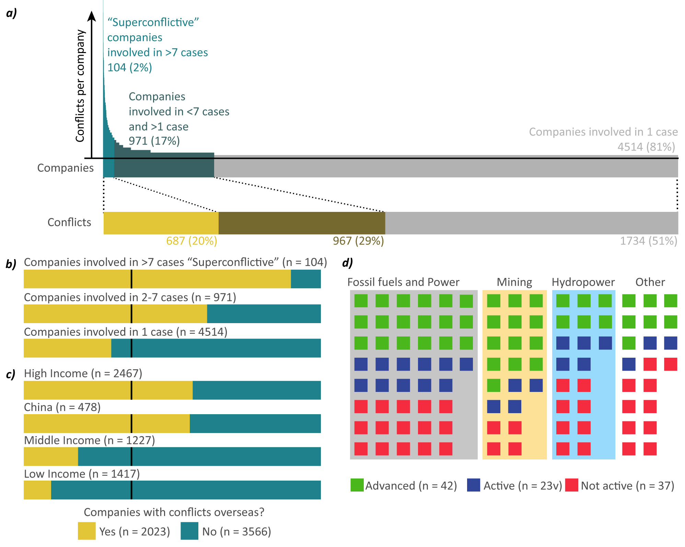***Figure 1. Ninety-six superconflictive companies, mostly MNCs from high-income countries, are involved in one-third of conflicts a)*** *The top chart shows the number of conflicts by company coloured by whether they are involved in more than seven (“superconflictive”, lighter blue), more than one (darker blue) or just one conflict. The dotted lines relate each successive company category to the cumulative number of conflicts they are involved in.* ***b,c)*** *Distribution of companies by number of conflicts reported or income group of the country of origin, coloured by whether they have conflicts overseas (yellow) or not (blue). The number of companies in each category is given in brackets. The vertical lines indicate the expected global ratio of companies with overseas conflicts (1732/5073)* ***d)*** *Representation of 96 superconflictive companies coloured by their adoption level of UN Global Compact and shadowed according to their economic sector.*

## 

## 4.2 MNCs are overrepresented in conflicts with commodities highly dense in energy, value, and virtual land and water

This section explores the regional distribution of companies and conflicts between high, middle and low-income countries and China. To that effect, a Sankey diagram linking the country of occurrence of each conflict with the country of origin of the companies involved, grouped by country income levels is shown in Figure 2a. In general terms, the results show that 33% of the companies involved in EJAtlas conflicts come from a country in another income group (bold colour in Figure 2a). Conflicts across income groups generally occur in middle (37%) and low (59%) income countries, while they mostly involve MNCs from high-income countries (76%) and China (15%). High-income and Chinese MNCs are more frequently involved in conflicts in middle and low-income countries than in countries in their income group, and together they represent 42% of the companies involved in conflicts in middle and low-income countries. In contrast, most of the companies from middle (87%) and low (98%) income countries are involved in conflicts in countries of their income group. Inverting the analysis, only 4% of companies involved in conflicts in high-income countries are from countries in other income groups. The figure is 11% for China and climbed to 41% and 48% for middle- and low-income countries respectively.

The relatively lower presence of Chinese companies in the EJAtlas compared with companies from high-income countries, despite their similar population sizes, would in principle hint to a relatively lower contribution towards environmental injustice than corporations from high-income countries. However, one should avoid jumping to conclusions given the regional sampling bias of the EJAtlas, as already discussed in the methodology section. In this vein, it is noteworthy to contrast the significantly higher number of cases in high-income countries compared to China (Figure 2). If anything, the ratio between company involvement and cases is approximately 2:1 for both high-income countries and China. Furthermore, half or more of conflicts involving companies from both high-income countries and China are in other income groups (50% for high-income and 61% for China).

To further explore the role of MNCs in operationalising ecologically unequal exchange, the commodities related to each conflict are compared between conflicts with and without foreign MNCs involved. The results show that the commodities overrepresented in conflicts with foreign MNCs involvement belong to three main groups: industrial plantation agriculture (cotton, corn, rice and soy), copper and mining preciosities (diamonds, gold, silver, rare metals, lithium), and oil and gas (Figure 2b). In contrast, land, tourism services, biological resources[3], coal, and all kinds of waste are underrepresented in conflicts with foreign MNCs involved.

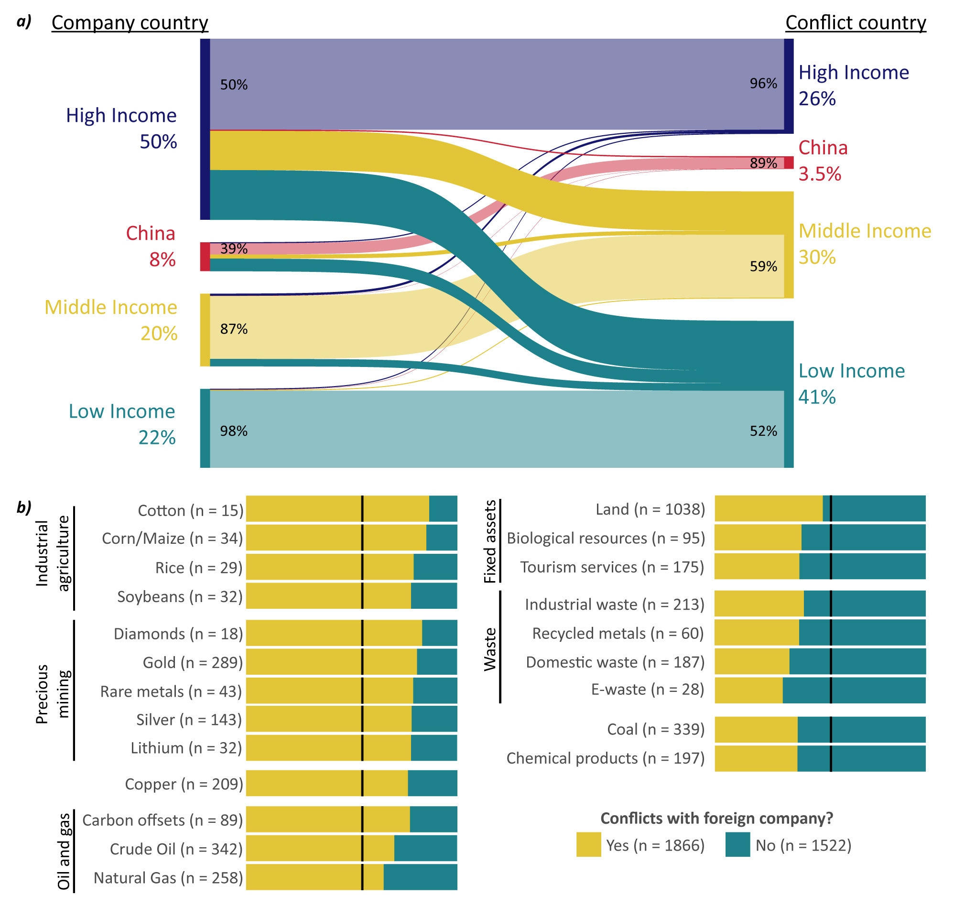

***Figure 2. Companies from the Global North drive conflicts mostly in the Global South and are overrepresented in conflicts over commodities with high embodied water, land, value and energy density. a)*** *Sankey diagram linking the income groups of companies’ countries with the income groups where their environmental conflicts occur. The large percentages indicate the distribution of company involvements by home (left) and host (right) income group (total n = 8851). The small percentages indicate the ratio of involvements respectively to (left) and from (right) the same income group. The same data broken down by geographic region can be found in Figure S1. The values behind this plot can be consulted in Table S2.* ***b)*** *Bar charts comparing conflicts with (yellow) or without (blue) foreign MNCs for different commodity codes. The vertical lines indicate the expected ratio of conflicts with foreign MNCs (1866/3388). Only (and all) commodities with significant differences are shown (Chi-squared test with Yates continuity correction, confidence value 0.05).*

## 4.3 Conflicts with foreign MNCs have more impacts and worse outcomes

The final question addressed is whether conflicts with foreign MNC involvement have more impacts and worse outcomes than those without foreign companies. This question lies at the heart of the *pollution heaven* vs *pollution halo* debate*.* The EJAtlas collects information on 41 impact categories divided into environmental, health, and socioeconomic divisions. A first overall assessment compares the total counts of visible environmental, health and socioeconomic impacts reported for conflicts with or without foreign companies (Figure 3a). Conflicts with foreign MNC involvement report significantly more environmental, health and socioeconomic impacts (p-values 0.01, 0.001 and <0.0001respectively). Environmental impacts are the category with the least overrepresentation, and the codes overrepresented in the presence of foreign companies (Biodiversity loss, Oil Spills, Deforestation, Food insecurity, Mine tailing spills) are largely explained by the overrepresentation of MNCs in mining, fossil fuels, and agroindustry sectors (Figure S2). Other environmental impact codes do not show a significant difference when foreign companies are involved. The most significant differences are in the socioeconomic impact category where all codes except for loss of landscape are significantly more reported when foreign MNCs are involved (Figure 3a, Figure S3).

One may also ask whether MNCs are associated with more impacts in conflicts abroad than domestically. Selecting only the conflicts with MNCs involvement in the database, it can be observed how in the instances where MNCs are involved in conflicts in their home country, the impacts are significantly underrepresented compared to when they ared involved in conflicts abroad (Figure S4). The only differences observed with the overall comparison between cases with and without foreign company involvement (Fig 3) are the similar impact in traditional knowledges, cultures and practices between MNCs conflicts domestically and abroad, a significant underrepresentation of trade union mobilisation and compensations outcomes when MNCs are involved in conflicts abroad.

As previously shown, two-thirds of the superconflictive companies in the EJAtlas take part in the UN Global Compact initiative (Figure 1d). It is thus justified to ask whether the UN voluntary programme fulfils its objective to engage companies in meeting their “fundamental responsibilities in the areas of human rights, labour, environment and anti-corruption” (UN Global Compact, 2024). In the area of human rights, the UN Global Compact encourages participant companies to comply with the UN Guiding Principles. In turn, the UN Guiding Principles mandate companies to pay “due regard to the different risks that may be faced by women and men” and give “special attention to both gender-based and sexual violence” in conflict-affected regions (UN Human Rights Council, 2011:6,10). However, gendered and violent impacts are the most disproportionately overrepresented in conflicts with foreign MNCs (Figure 3a). Additionally, the UN Guiding Principles demand special consideration of “groups or populations that may be at heightened risk of vulnerability or marginalization” (UN Human Rights Council, 2011:17,19) with specific regard for “Indigenous Peoples, women, national or ethnic minorities” (UN Human Rights Council, 2011:8). This opens the question of whether foreign companies have worse impacts on marginalised groups in general, and on Indigenous and traditional peoples in particular. The EJAtlas does not directly document whether a particular group has been impacted, but it records which groups have mobilised against a project. In this analysis, the mobilisation of a group is taken as a proxy for perceived negative impacts on a group’s health, culture, livelihood and territory. The analysis shows that Indigenous groups and traditional communities, and racially discriminated groups are significantly overrepresented in EJAtlas conflicts with foreign MNC involvement (p-values <0.0001, Figure 3b). Additionally, the EJAtlas data reveals that the loss of traditional knowledge, practices and cultures is overrepresented in the conflicts involving MNCs (p-value <0.0001).

Another noticeable finding is the overrepresentation of trade unions in conflicts with the presence of foreign MNCs (p-value 0.03). This probably reflects that MNCs' corporate and labour arrangements facilitate the mobilisation of trade unions, whereas domestic companies are more likely to have small structures and local political dynamics that are not as prone to unionised resistance. Trade unionist’s concerns are mainly related to pay and safety conditions, with grievances generally focusing on environmental health concerns (Navas *et al.,* 2022). Lastly, the involvement of international EJOS stands out as the most overrepresented of the mobilised actors categories (p-value <0.0001).

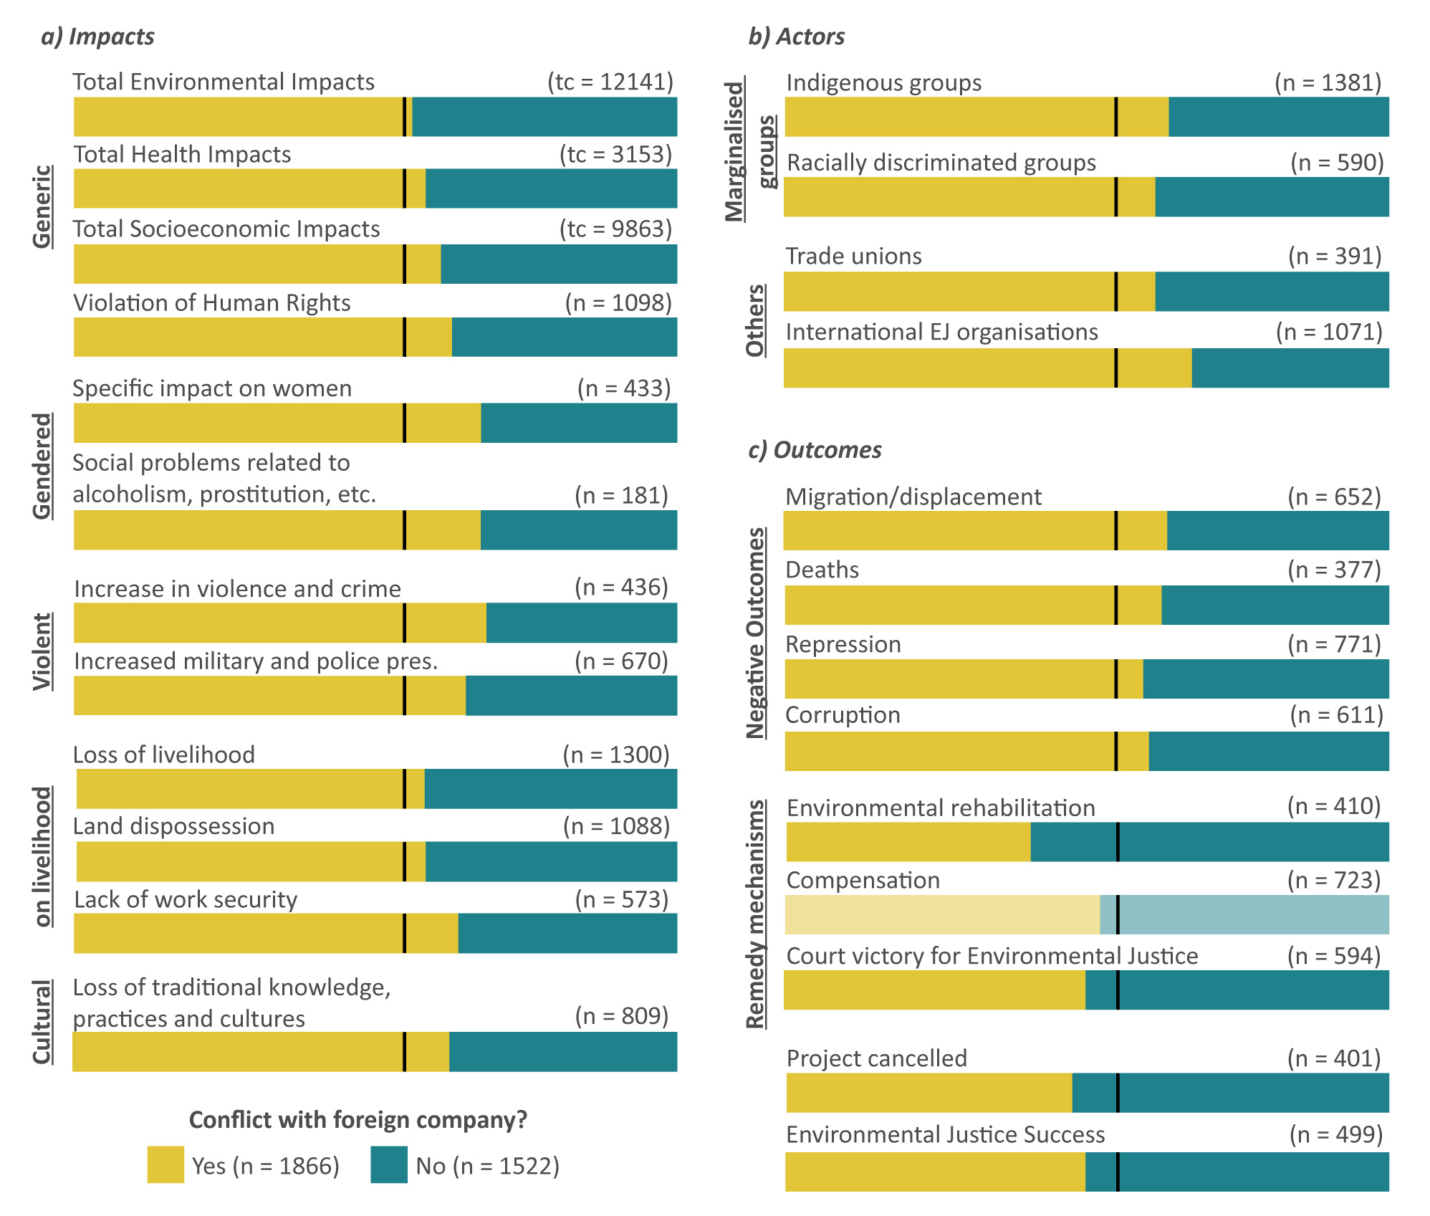

***Figure 3. Comparison of impact categories (a), actors mobilised (b), and conflict outcomes (c)*** ***between conflicts with (yellow) and without (blue) foreign companies involved.*** *Bar plots show the observed ratio between conflicts with and without foreign companies of reports for each code compared to an overlaid black line with the expected ratio based on the relative abundance of conflicts with foreign MNCs (1866/3388). The total count of impacts across all conflicts is given as (tc), and the total number of reports for a given impact, actor or outcome code is given as (n) above each bar. All codes in the figure except compensation show significant differences between conflicts with and without foreign companies (Pearson Chi-square test with 0.05 confidence level). All socioeconomic impact codes can be seen in Figure S3, all codes and test statistics can be accessed in the repository associated with this publication.*

Finally, the association of foreign companies' involvement with better or worse outcomes in environmental conflicts from the perspective of affected communities is tested. Overall, negative outcomes such as displacement, environmental defender assassinations, repression and corruption are significantly overrepresented in conflicts with the involvement of foreign companies (Figure 5a). It is worth highlighting that the UN Global Compact Principles demand that companies “make sure that they are not complicit in human rights abuses” and that “Businesses should work against corruption in all its forms, including extortion and bribery” (UN Global Compact, 2024). In contrast, outcomes regarded as remedy actions by the UN Guiding Principles such as compensation, environmental rehabilitation, or a court victory for environmental justice (UN Human Rights Council, 2011: 22) are significantly underrepresented in conflicts with the involvement of foreign companies. In general, conflictive projects with foreign company involvement are significantly less likely to be cancelled (p-value 0.003) and less frequently lead to the perception of environmental justice (p-value 0.01). Distinctively, the underrepresentation of environmental rehabilitation (p-value <0.0001) is much more marked than compensation (p-value 0.04) and court victory for environmental justice (p-value 0.02).

# Discussion

The “long tail” of corporations involved in a single environmental conflict (Figure 1a) supports the idea that global environmental injustice is partly driven by a widely adopted corporate culture selected by a particular model of economic organisation. A liberalised global market imposes an international race-to-the-bottom where “the intense competition among developing countries to attract FDI may lead to relaxing of environmental standards for foreign firms, thus encouraging firms” that explains the *pollution haven hypothesis* (Demena & Afesorgbor, 2020:3; Balsalobre-Lorente *et al.,* 2019). The same search for competitive advantages would explain a corporate race-to-the-top to maximise resource extraction profits by shifting the costs of the social and ecological impacts to local communities and ecosystems (Kapp, 1950; Martinez-Alier, 2012).

Beyond a conducive business environment, at the other side of the spectrum,a select number of 104 superconflictive corporations are particularly responsible for the emergence of environmental conflicts globally. Hence, a policy and activism focus on these firms is duly placed and can make strides in the consecution of environmental justice. The concentration of conflicts in just over a hundred companies contrasts with the diversity of local campaigns organising resistance to their projects. Local environmental justice and neighbour organisations are mobilised in two-thirds of the conflicts in the EJAtlas (Scheidel *et al.,* 2020). At least in part, environmental justice struggles can be seen as a conflict between centralising and decentralising forces. While MNCs represent a force that concentrates power and flattens out alternative ways of organising society, environmental justice organisations usually embrace a “pluriverse of alternatives” (Demaria *et al.,* 2023) which nonetheless “frequently converge over aims to reassert customary practices and to protect lands and livelihoods from adverse environmental change” (Scheidel *et al.,* 2020: 3, citing Anguelovski and Martínez Alier; 2014).

As has been pointed out by other authors, voluntary corporate sustainability initiatives are largely focused on corporate self-reporting, systematically excluding the voices of communities affected by corporate operations (Maher, 2020). This has led critical scholars to argue that MNCs are joining voluntary initiatives with questionable enforcement arrangements (King et al., 2011) as a public relations exercise to preempt government regulation and counter legitimate environmental concerns (Sherman, 2020) while offering little socio-ecological mitigation measures to extractive operations (Aragón-Correa *et al.*, 2020). In this vein, critical scholars have theorised that corporate voluntary initiatives are a means to cement the power of MNCs while further marginalising the realities of those living on the frontlines of corporate extractivism (Banerjee, 2008). This has led to criticisms of the UN Global Compact as a corporate “bluewashing” mechanism that propels corporate participants' social legitimacy thanks to the UN's moral reputation, and at the expense of the people most marginalised by the world economy (Berliner & Prakash, 2015; Seele, 2007; Macellari *et al.,* 2021). The results presented support this view, showing that despite their involvement in the UN Global Compact, superconflictive companies continue to drive socio-environmental impacts and spur resistance by local communities.

The geographic distribution of companies and conflicts reflects a general pattern of MNCs from the Global North and China disproportionately engaged in conflicts occurring in the Global South. This trend largely parallels the ecologically unequal exchange flows between country income groups shown in a recent study (Dorninger *et al.,* 2021). This would support the asssumption that companies from the Global North with institutional, social, infrastructural, and historical ties with their countries of origin are more likely that companies from the Global South to concentrate resources in core world regions. Considering that a significant proportion of global trade is likely to happen within vertically integrated companies (Lakatos & Ohnsorge, 2017), this evidence suggests that MNCs are key actors driving ecologically unequal exchange.Furthermore, this evidence would lend moderate support to the hypothesis that China operates as an economic core similar to high-income countries. Chinese companies also go to Middle and low-income countries to establish extractive operations, shifting socio-environmental costs to the world peripheries and sparking environmental conflicts. An interesting observation is the relative lack of presence of high-income companies in China, and Chinese companies in high-income countries. This may point to a mutually isolated bipolar extractive order where Chinese and Western companies compete for resources in the Global South while keeping their respective home economies largely closed to each others’ extractive companies.

The common trait of commodities overrepresented in conflicts with foreign MNCs is their high density, either in energy, value or virtual land and water per weight terms. Industrial agriculture grains are highly dense in virtual land and water (Qiang *et al.,* 2020; Mekonnen & Hoekstra, 2011), mining preciosities are highly dense in value, and oil and gas are highly dense in energy (Smil, 2015). On the other hand, the commodities underrepresented in conflicts with foreign companies have either a low value density (waste) or a low energy density (coal). This pattern highlights that the efficient transport of goods is an integral part of the resource appropriation that defines ecologically unequal exchange. High virtual land, water, value, and energy densities reduce the relative cost of transport and facilitate the resource drain from the Global South to the Global North. Concomitantly, highly dense commodities also facilitate shifting socioenvironmental impacts from economic cores to peripheries (Würtenberger *et al.,* 2006). The importance of transport is also highlighted by the underrepresentation of geographically-fixed commodities, such as land, tourism services, and biological resources in conflicts with foreign companies. The corollary is the notable exception of carbon offsets, a waste product with low value density but overrepresented in conflicts with foreign companies. However, in this case, transport is rendered unnecessary by a global carbon market based on the disputed commensurability of all carbon dioxide molecules in the atmosphere.

The combined evidence of the geographical distribution of conflicts and companies, and the commodity analysis lends strong support to the conclusion that MNCs are the key actors that operationalise cost-shifting and ecologically unequal exchange. They do so by extracting, transporting and commercialising highly dense commodities to efficiently drain land, materials, energy and value-added from the Global South towards the Global North, as already quantified by previous studies (Hickel *et al.,* 2022). The EJAtlas mainly includes extractive companies, so it is not possible to speak about another key resource: labour. However, one can hypothesise that MNCs will be disproportionately interested in the global trade of manufactured goods which have the highest working person-hours density per weight.

Turning the discussion towards the impacts of foreign company operations, the environmental impacts comparative results would only give minimal support to the *pollution haven hypothesis* in the strict environmental sense (Figure 3). However, the comparative results unequivocally show that the presence of foreign MNCs correlates with more socioeconomic impacts (see also Table S3). This evidence is a testament to the reality of the environmentalism of the poor (Martínez-Alier, 2003), mostly from the Global South, that does not defend the natural world merely for its intrinsic value, nor does it defend it to attain a transactional gain, it rather defends the environment as an essential component of traditional cultural, social and economic systems (Whiteman, 2009).In this sense, many environmental conflicts can also be seen as “cultural” and “ontological struggles” that pit the forces of development, represented by MNCs and their enablers, against the pursuit of cultural affirmation by Indigenous Peoples and traditional communities that resist what they perceive as the false promise of development that threatens their cultures and ways of life (Escobar 2011: 16; 2019: 13).

The overrepresentation of international organisation mobilising in conflicts with foreign companies is not unexpected and responds to the need for international networks that span the geographies where the conflicts occur and the geographies where corporate decisions are taken, to organise a global resistance to prevent environmental and human rights violations by MNCs. This evidence indicates that one of the ways in which the global environmental justice movement weaves itself is through institutional links that follow MNCs' international operations (Martínez-Alier *et al.,* 2016). In this sense, the globalisation of economic flows and liberalisation of trade has been a driver for the internationalisation of the environmental justice movement (Faber, 2005). The presence of international environmental justice movements is especially relevant in those conflictive MNCs operations in Global South countries with limited political freedoms where a repressive State facilitates extractive projects at the expense of the local population. In such cases, international alliances are critical to leverage pressure points in the jurisdictions where MNCs are domiciled, which generally are in Global North countries with relatively more political freedom to confront MNCs. Examples of such dynamics can be found in the court cases against Shell operations in Nigeria in Dutch courts (Enneking, 2019; Ngwakwe, 2021), the case filed against TotalEnergies in France for its EACOP project in Uganda and Tanzania (Llavero-Pasquina *et al.,* 2024), or the lawsuit brought against BHP by 720,000 Brazilians for the Fundão (Samarco) iron ores tailing dam failure in the UK (Safari *et al.,* 2020).

Finally, the underrepresentation of remedy measures like environmental rehabilitation or court rulings for environmental justice contrasts with the lack of significant differences in economic compensation between conflicts with and without foreign companies. This suggests that MNCs have little interest in maintaining local ecological conditions compared with domestic companies and that compensation seems to be cheaper and/or more convenient than environmental rehabilitation for MNCs. This observation illustrates that oftentimes the cost-benefit analysis of MNCs favours economic compensation rather than preservation or restoration. When Martínez-Alier (2003:30) explains that “the poor sell cheap, not out of choice but out of lack of power”, one is reminded that power asymmetries between MNCs giants and local organisations are the defining feature of many environmental conflicts.

# Conclusion

This article contributes to the growing field of statistical political ecology focusing on the involvement of MNCs in environmental conflicts with the EJAtlas database. It complements previous works focusing on Indigenous participants (Scheidel *et al.,* 2020, 2023), women (Tran and Hanacek, 2023), and working-class groups (Navas *et al.,* 2022). In particular, this article advances knowledge in three key areas:

First, the analysis of the EJAtlas company database suggests that a select number of superconflictive corporations, mostly MNCs, are a significant driver of environmental injustice globally. However, an economic context that rewards resource extraction maximisation through socioecological cost-shifting also explains why several thousand companies contribute to environmental injustice as documented in the EJAtlas. In practice, the results support that campaigns targeting superconflictive companies are indeed important to advance environmental justice in the large number of conflicts they are involved in. Yet, it is equally necessary for the advancement of environmental justice to challenge imperant development models oriented towards economic growth and an endless increase in material and energy consumption. Further research will determine whether the emergence of superconflictive companies is explained by firm size, their activity sector, a particular disregard for local communities and the environment, a fixation by environmental justice advocates, or a combination of these.

Second, the analysis provides evidence indicating that MNCs are key actors in ecological unequal exchange and socio-ecological cost-shifting from the Global North towards the Global South. Interpreting the evidence from the EJAtlas, the liberalisation of globalised trade and the promotion of FDI enable MNCs from the Global North to extract and appropriate resources from the Global South, distinctively through commodities highly dense in energy, value, and virtual land and water. In addition, the conflicts involving MNCs lead to more frequent socioeconomic impacts, worse outcomes and less remedial action. Thus, these findings support the *pollution haven hypothesis* and support environmental justice campaigns around the world that challenge the institutions upholding the globalised free trade system. Free Trade Agreements, ISDS, WTO rules and IMF conditional debt relief packages are targeted by environmental justice activists, mostly from the Global South, because they perceive trade liberalisation and export-oriented policy as a threat of exacerbated socio-ecological cost-shifting (Hickel *et al.,* 2022). Further research can determine whether domestic companies are involved in conflicts with fewer impacts and negative outcomes due to their local knowledge and relations, the size or sectors of their projects, or because local communities feel more threatened by foreign actors.

Third, the results presented call into question the effectiveness of the UN Global Compact and other similar voluntary initiatives. A large proportion of the superconflictive MNCs identified participate in the UN programme, and yet MNCs are involved in conflicts that report more impacts and worse outcomes than conflicts with only domestic companies involved. This finding supports calls for binding rules and accountability to replace voluntary pledges and certifications (Martín-Ortega, 2014). Additionally, this study challenges the validity of human rights benchmarks[4] and ESG ratings[5] that highly rank some of the superconflictive companies exposed in this study. Further research can address the chasm between the image of good corporate citizens painted by ESG ratings and the serious grievances expressed by environmental defenders facing the impacts of corporate extractivism.

Most generally, this study has shown that the perspective from which one addresses the question of the socio-ecological impacts of FDI and corporate sustainability can diametrically change the answer. Most studies into FDI and environmental corporate initiatives systematically take the perspective of the company while marginalising those at the receiving end of environmental injustice. Such approaches primarily draw their data from corporate or governmental reporting and are often oriented towards maximising economic growth, investment returns and corporate profit. To contrast this approach, the present research draws from the experiences of the communities resisting corporate operations by selecting the EJAtlas database as a source. The conclusions of this study challenge longstanding assumptions in the development economics and management studies fields and show that the EJAtlas data can be used as a powerful bottom-up data counterbalance to development, ESG and CSR narratives. There is power in the collection of data and the election of data sources. Engaged academic studies can contribute towards environmental justice by evaluating corporate socio-ecological performance based on the lived experiences and testimony of those physically confronting its extractive operations.

# References

Alsayegh, M. F., Abdul Rahman, R., & Homayoun, S. (2020). Corporate economic, environmental, and social sustainability performance transformation through ESG disclosure. *Sustainability*, *12*(9), 3910.

Anand, R. (2017). Free-market economics, multinational corporations and environmental justice in a globalized world. In *The Routledge Handbook of Environmental Justice* (pp. 479-489). Routledge.

Anguelovski, I., & Alier, J. M. (2014). The ‘Environmentalism of the Poor’revisited: Territory and place in disconnected glocal struggles. *Ecological Economics*, *102*, 167-176.

Aragòn-Correa, J. A., Marcus, A. A., & Vogel, D. (2020). The effects of mandatory and voluntary regulatory pressures on firms’ environmental strategies: A review and recommendations for future research. *Academy of Management Annals*, *14*(1), 339-365.

Aust, V., Morais, A. I., & Pinto, I. (2020). How does foreign direct investment contribute to Sustainable Development Goals? Evidence from African countries. *Journal of Cleaner Production*, *245*, 118823.

Balsalobre-Lorente, D., Gokmenoglu, K. K., Taspinar, N., & Cantos-Cantos, J. M. (2019). An approach to the pollution haven and pollution halo hypotheses in MINT countries. *Environmental Science and Pollution Research*, *26*, 23010-23026.

Banerjee, S. B. (2008). Corporate social responsibility: The good, the bad and the ugly. *Critical sociology*, *34*(1), 51-79.

Berenschot, W., Dhiaulhaq, A., Hospes, O., Adriana, R., & Poetry, E. (2022). Anti-corporate activism and collusion: The contentious politics of palm oil expansion in Indonesia. *Geoforum*, *131*, 39-49.

Berliner, D., & Prakash, A. (2015). “Bluewashing” the Firm? Voluntary Regulations, Program Design, and Member Compliance with the U nited N ations G lobal C ompact. *Policy Studies Journal*, *43*(1), 115-138.

Bieler, A., & Morton, A. D. (2016). Uneven and Combined Development and Unequal Exchange: The Second Wind of Neoliberal ‘Free Trade'?. In *Free Trade and Transnational Labour* (pp. 35-45). Routledge.

Blanco, L., Gonzalez, F., & Ruiz, I. (2013). The impact of FDI on CO2 emissions in Latin America. *Oxford Development Studies*, *41*(1), 104-121.

Boele, R., Fabig, H., & Wheeler, D. (2001). Shell, Nigeria and the Ogoni. A study in unsustainable development: I. The story of Shell, Nigeria and the Ogoni people–environment, economy, relationships: conflict and prospects for resolution 1. *Sustainable development*, *9*(2), 74-86

Bontempi, A., Venturi, P., Del Bene, D., Scheidel, A., Zaldo-Aubanell, Q., & Zaragoza, R. M. (2023a). Conflict and conservation: On the role of protected areas for environmental justice. *Global Environmental Change*, *82*, 102740.

Bontempi, A., Del Bene, D., & Di Felice, L. J. (2023b). Counter-reporting sustainability from the bottom up: the conflict of the construction company WeBuild and dam-related conflicts. *Journal of Business Ethics*, *182*(1), 7-32.

Borensztein, E., De Gregorio, J., & Lee, J. W. (1998). How does foreign direct investment affect economic growth?. *Journal of international Economics*, *45*(1), 115-135.

Brock, A., & Dunlap, A. (2018). Normalising corporate counterinsurgency: Engineering consent, managing resistance and greening destruction around the Hambach coal mine and beyond. *Political Geography*, *62*, 33-47.

Cavanagh, C., & Benjaminsen, T. A. (2014). Virtual nature, violent accumulation: The ‘spectacular failure’of carbon offsetting at a Ugandan National Park. *Geoforum*, *56*, 55-65.

Chittoor, R., & He, Y. (2023). Institutional environments, cross-national distances, and MNEs’ corporate social irresponsibility in host countries. In *Research Handbook on International Corporate Social Responsibility* (pp. 187-204). Edward Elgar Publishing.

Cole, M. A., Elliott, R. J., & Zhang, L. (2017). Foreign direct investment and the environment. *Annual Review of Environment and Resources*, *42*, 465-487.

Daly, H. E., & Farley, J. (2011). *Ecological economics: principles and applications*. Island press.

Dehm, J. (2022). Environmental Justice Challenges to International Economic Ordering.

Demaria, F., Kothari, A., Salleh, A., Escobar, A., & Acosta, A. (2023). Post-development: From the Critique of Development to a Pluriverse of Alternatives. In *The Barcelona School of Ecological Economics and Political Ecology: A Companion in Honour of Joan Martinez-Alier* (pp. 59-69). Cham: Springer International Publishing.

Demena, B. A., & Afesorgbor, S. K. (2020). The effect of FDI on environmental emissions: Evidence from a meta-analysis. *Energy policy*, *138*, 111192.

Doytch, N. (2020). The impact of foreign direct investment on the ecological footprints of nations. *Environmental and Sustainability Indicators*, *8*, 100085.

Doytch, N., & Ashraf, A. (2022). The ecological footprints of greenfield FDI and cross-border M&A Sales. *Environmental Modeling & Assessment*, *27*(6), 935-951.

Dorninger, C., Hornborg, A., Abson, D. J., Von Wehrden, H., Schaffartzik, A., Giljum, S., ... & Wieland, H. (2021). Global patterns of ecologically unequal exchange: Implications for sustainability in the 21st century. *Ecological economics*, *179*, 106824.

Dunlap, A., & Fairhead, J. (2014). The militarisation and marketisation of nature: An alternative lens to ‘climate-conflict’. *Geopolitics*, *19*(4), 937-961.

Dunning, J. H., & Lundan, S. M. (2008). *Multinational enterprises and the global economy*. Edward Elgar Publishing.

Enneking, L. F. (2019). Transnational human rights and environmental litigation: a study of case law relating to shell in Nigeria. *Human rights in the extractive industries: Transparency, participation, resistance*, 511-551.

Escobar, A. (2011). *Encountering development: The making and unmaking of the Third World* (Vol. 1). Princeton University Press.

Escobar, A. (2019). Thinking-feeling with the Earth: Territorial Struggles and the Ontological Dimension of the Epistemologies of the South. In *Knowledges born in the struggle* (pp. 41-57). Routledge.

Faber, D. (2005). Building a transnational environmental justice movement: Obstacles and opportunities in the age of globalization. In: Bandy, J., Smith, J. (eds) *Coalitions across borders: Transnational protest and the neoliberal order*, pp.43-68. Lanham: Rowman & Littlefield.

Fiaschi, D., Giuliani, E., & Nieri, F. (2017). Overcoming the liability of origin by doing no-harm: Emerging country firms’ social irresponsibility as they go global. *Journal of World Business*, *52*(4), 546-563.

Fraser, M., Haigh, L., & Soria, A. C. (2023). The circularity gap report 2023.

Fussler, C., Cramer, A., & Van der Vegt, S. (Eds.). (2017). *Raising the bar: Creating value with the UN Global Compact*. Routledge.

Georgescu-Roegen, N. (1971). *The entropy law and the economic process*. Harvard university press.

Giampietro, M., & Mayumi, K. (2018). Unraveling the complexity of the Jevons Paradox: The link between innovation, efficiency, and sustainability. *Frontiers in Energy Research*, *6*, 26.

Giuliani, E., & Macchi, C. (2014). Multinational corporations’ economic and human rights impacts on developing countries: A review and research agenda. *Cambridge journal of economics*, *38*(2), 479-517.

Hickel, J., Dorninger, C., Wieland, H., & Suwandi, I. (2022). Imperialist appropriation in the world economy: Drain from the global South through unequal exchange, 1990–2015. *Global Environmental Change*, *73*, 102467.

Hornborg, A. (1998). Towards an ecological theory of unequal exchange: articulating world system theory and ecological economics. *Ecological economics*, *25*(1), 127-136.

King, A., Prado, A. M., & Rivera, J. (2011). Industry self-regulation and environmental protection.

Kramer, M. R., & Porter, M. (2011). *Creating shared value* (Vol. 17). Boston, MA, USA: FSG.

Lakatos, C., & Ohnsorge, F. (2017). Arm's-length trade: a source of post-crisis trade weakness. *World Bank Policy Research Working Paper*, (8144).

Lau, L. S., Choong, C. K., & Eng, Y. K. (2014). Investigation of the environmental Kuznets curve for carbon emissions in Malaysia: do foreign direct investment and trade matter?. *Energy policy*, *68*, 490-497.

Le Billon, P., & Lujala, P. (2020). Environmental and land defenders: Global patterns and determinants of repression. *Global Environmental Change*, *65*, 102163.

Llavero-Pasquina, M., Navas, G., Cantoni, R., & Martínez-Alier, J. (2024). The political ecology of oil and gas corporations: TotalEnergies and post-colonial exploitation to concentrate energy in industrial economies. Energy Research & Social Science, 109, 103434.

Macellari, M., Yuriev, A., Testa, F., & Boiral, O. (2021). Exploring bluewashing practices of alleged sustainability leaders through a counter-accounting analysis. *Environmental Impact Assessment Review*, *86*, 106489.

Maher, R. (2020). De-contextualized corporate human rights benchmarks: Whose perspective counts? See disclaimer. *Business and Human Rights Journal*, *5*(1), 156-163.

Mathews, J. A. (2006). Catch-up strategies and the latecomer effect in industrial development. *New political economy*, *11*(3), 313-335.

Martin-Ortega, O. (2014). Human rights due diligence for corporations: from voluntary standards to hard law at last?. *Netherlands Quarterly of Human Rights*, *32*(1), 44-74.

Martinez-Alier, J. (2003). *The Environmentalism of the poor: a study of ecological conflicts and valuation*. Edward Elgar Publishing.

Martinez-Alier, J., Kallis, G., Veuthey, S., Walter, M., & Temper, L. (2010). Social metabolism, ecological distribution conflicts, and valuation languages. *Ecological Economics*, *70*(2), 153-158.

Martínez-Alier, J. (2012). Social metabolism, environmental cost-shifting and valuation languages. *Towards an Integrated Paradigm in Heterodox Economics: Alternative Approaches to the Current Eco-Social Crises*, 94-110.

Martinez-Alier, J., Temper, L., Del Bene, D., & Scheidel, A. (2016). Is there a global environmental justice movement?. *The Journal of Peasant Studies*, *43*(3), 731-755.

Martínez-Alier, J. (2023a). Corporate social irresponsibility and systematic lack of environmental liability. In *Land, Water, Air and Freedom* (pp. 605-631). Edward Elgar Publishing.

Martínez-Alier, J. (2023b). *Land, Water, Air and Freedom: The Making of World Movements for Environmental Justice*. Edward Elgar Publishing.

Mekonnen, M. M., & Hoekstra, A. Y. (2011). The green, blue and grey water footprint of crops and derived crop products. *Hydrology and earth system sciences*, *15*(5), 1577-1600.

Methmann, C. (2013). The sky is the limit: Global warming as global governmentality. *European Journal of International Relations*, *19*(1), 69-91.

Muradian, R., & Martinez-Alier, J. (2001). Trade and the environment: from a ‘Southern’ perspective. *Ecological Economics*, *36*(2), 281-297.

Navas, G., D'Alisa, G., & Martínez-Alier, J. (2022). The role of working-class communities and the slow violence of toxic pollution in environmental health conflicts: A global perspective. *Global Environmental Change*, *73*, 102474.

Ngwakwe, C. C. (2021). Niger Delta Oil Spill Case against the Shell Company at the Hague: The Future of Corporate Environmental Responsibility. *Acta Universitatis Danubius. Juridica*, *17*(2), 27-39.

Omri, A., Nguyen, D. K., & Rault, C. (2014). Causal interactions between CO2 emissions, FDI, and economic growth: Evidence from dynamic simultaneous-equation models. *Economic Modelling*, *42*, 382-389.

Paul, J., & Feliciano-Cestero, M. M. (2021). Five decades of research on foreign direct investment by MNEs: An overview and research agenda. *Journal of business research*, *124*, 800-812.

Pellegrini, L., Arsel, M., Orta-Martínez, M., & Mena, C. F. (2020). International investment agreements, human rights, and environmental justice: The Texaco/Chevron case from the Ecuadorian Amazon. *Journal of International Economic Law*, *23*(2), 455-468.

Qiang, W., Niu, S., Liu, A., Kastner, T., Bie, Q., Wang, X., & Cheng, S. (2020). Trends in global virtual land trade in relation to agricultural products. *Land use policy*, *92*, 104439.

Rasche, A., Waddock, S., & McIntosh, M. (2013). The United Nations global compact: Retrospect and prospect. *Business & Society*, *52*(1), 6-30.

Ruggie, J. G. (2020). The paradox of corporate globalization: Disembedding and reembedding governing norms. M-RCBG Faculty Working Paper Series, 1.

Saes, B. M., Bene, D. D., Neyra, R., Wagner, L., & Martínez-Alier, J. (2021). Environmental justice and corporate social irresponsibility: the conflict of the mining company Vale SA. *Ambiente & Sociedade*, *24*, e0014.

Safari, M., Bicudo de Castro, V., & Steccolini, I. (2020). The interplay between home and host logics of accountability in multinational corporations (MNCs): the case of the Fundão dam disaster. *Accounting, Auditing & Accountability Journal*, *33*(8), 1761-1789.

Sauvant, K. P., & Mann, H. (2019). Making FDI more sustainable: Towards an indicative list of FDI sustainability characteristics. *The Journal of World Investment & Trade*, *20*(6), 916-952.

Scheidel, A., Del Bene, D., Liu, J., Navas, G., Mingorría, S., Demaria, F., ... & Martínez-Alier, J. (2020). Environmental conflicts and defenders: A global overview. *Global Environmental Change*, *63*, 102104.

Scheidel, A., Fernández-Llamazares, Á., Bara, A. H., Del Bene, D., David-Chavez, D. M., Fanari, E., ... & Whyte, K. P. (2023). Global impacts of extractive and industrial development projects on Indigenous Peoples’ lifeways, lands, and rights. *Science advances*, *9*(23), eade9557.

Seele, P. (2007). Is blue the new green. *Colors of the Earth in Corporate PR and Advertisement to communicate Ethical Commitment and Responsibility*.

Shah, MH, & Khan, Y.(2016). Trade Liberalization and FDI Inflows in Emerging Economies. *Business & Economic Review*, *8*(1), 35-52.

Sherman, J. (2020). Beyond CSR: The Story of the UN Guiding Principles on Business and Human Rights.

Smil, V. (2015). *Power density: a key to understanding energy sources and uses*. MIT press.

Spash, C. L. (2020). A tale of three paradigms: Realising the revolutionary potential of ecological economics. *Ecological Economics*, *169*, 106518.

Temper, L., Del Bene, D., & Martinez-Alier, J. (2015). Mapping the frontiers and front lines of global environmental justice: the EJAtlas. *Journal of Political Ecology*, *22*(1), 255-278.

Temper, L., Demaria, F., Scheidel, A., Del Bene, D., & Martinez-Alier, J. (2018). The Global Environmental Justice Atlas (EJAtlas): ecological distribution conflicts as forces for sustainability. *Sustainability Science*, *13*(3), 573-584.

Temper, L., Avila, S., Del Bene, D., Gobby, J., Kosoy, N., Le Billon, P., ... & Walter, M. (2020). Movements shaping climate futures: A systematic mapping of protests against fossil fuel and low-carbon energy projects. *Environmental Research Letters*, *15*(12), 123004.

Tran, D., & Hanaček, K. (2023). A global analysis of violence against women defenders in environmental conflicts. *Nature sustainability*, 1-9.

Ullah, S., Adams, K., Adams, D., & Attah-Boakye, R. (2021). Multinational corporations and human rights violations in emerging economies: Does commitment to social and environmental responsibility matter?. *Journal of Environmental Management*, *280*, 111689.

UN Human Rights Council. (2011). Guiding Principles on Business and Human Rights: Implementing the United Nations’ “Protect, Respect and Remedy” Framework, A/HRC/17/31. <https://documents.un.org/doc/undoc/gen/g11/121/90/pdf/g1112190.pdf>

UNCTAD. (2024). World Investment Report 2024. <https://unctad.org/system/files/official-document/wir2024_en.pdf>

UNGC (2022). Annual Implementation Survey 2021. <https://unglobalcompact.org/what-is-gc/our-work/implementation>

UN Global Compact (2024). The Ten Principles of the UN Global Compact. <https://unglobalcompact.org/what-is-gc/mission/principles>

van Bommel, K., Rasche, A., & Spicer, A. (2023). From values to value: The commensuration of sustainability reporting and the crowding out of morality. *Organization & Environment*, *36*(1), 179-206.

Yaşın, Z. T. (2023). The Socio-ecological Question, the Global Environmental Justice Movement and Anti-systemic Environmentalism. *Perspectives on Global Development and Technology*, *21*(5-6), 466-489.

Whiteman, G. (2009). All my relations: understanding perceptions of justice and conflict between companies and indigenous peoples. *Organization studies*, *30*(1), 101-120.

West, T. A., Börner, J., Sills, E. O., & Kontoleon, A. (2020). Overstated carbon emission reductions from voluntary REDD+ projects in the Brazilian Amazon. *Proceedings of the National Academy of Sciences*, *117*(39), 24188-24194.

Würtenberger, L., Koellner, T., & Binder, C. R. (2006). Virtual land use and agricultural trade: Estimating environmental and socio-economic impacts. *Ecological Economics*, *57*(4), 679-697.

Zarsky, L. (1999). Havens, halos and spaghetti: untangling the evidence about foreign direct investment and the environment. *Foreign direct Investment and the Environment*, *13*(8), 47-74.

Zhang, C., & Zhou, X. (2016). Does foreign direct investment lead to lower CO2 emissions? Evidence from a regional analysis in China. *Renewable and Sustainable Energy Reviews*, *58*, 943-951.

Zhu, H., Duan, L., Guo, Y., & Yu, K. (2016). The effects of FDI, economic growth and energy consumption on carbon emissions in ASEAN-5: evidence from panel quantile regression. *Economic Modelling*, *58*, 237-248.

# Data Availability

The R code, chi-squared tables and plots to produce all figures of this study can be found in the associated GitHub repository: LINK missing to preserve anonymity, the files are attached in the submission

The raw conflicts and company datasets can be requested from the EJAtlas:  
<https://ejatlas.org/backoffice/cms/en/data-use-policy/>

1. https://datahelpdesk.worldbank.org/knowledgebase/articles/906519-world-bank-country-and-lending-groups
2. A set of definitions of these codes can be accessed in the EJAtlas website https://ejatlas.org/backoffice/cms/en/definitions/
3. Biological resources is a rather general code that is selected in an heterogeneous sample of conflicts and should be analysed with caution. In some cases it indicates that biological resources used for place-based livelihoods and traditions are being impacted by urban, industrial or extractive developments. In other cases it involves conservation projects about a particular species or ecosystem, which also has a strong place attachment. A few other cases involve genetic resources, such as cases of biopiracy, GMO or seed conflicts, which would not have a particular place attachment.
4. See the Corporate Human Rights Benchmark <https://www.worldbenchmarkingalliance.org/publication/chrb/rankings/>
5. See the S&P Global ESG score where superconflictive companies systematically get high scores

   <https://www.spglobal.com/esg/scores/>